ASSIGNMENT 05
Q1. Use Copilot to identify and summarize missing values in the dataset.
SOL1: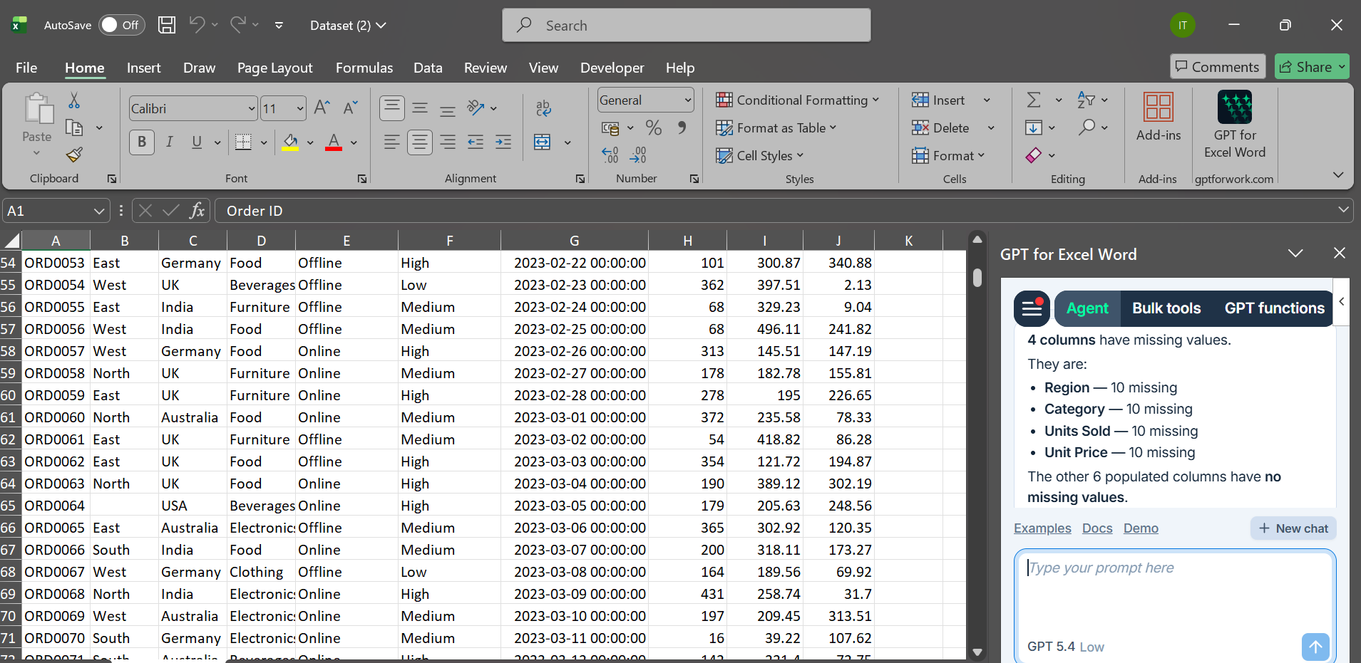
We have found 4 columns having missing values
Region , Category, Unit Sold, Unit price
Q2. Use Copilot to fill missing values in the region and category columns.
SOL2: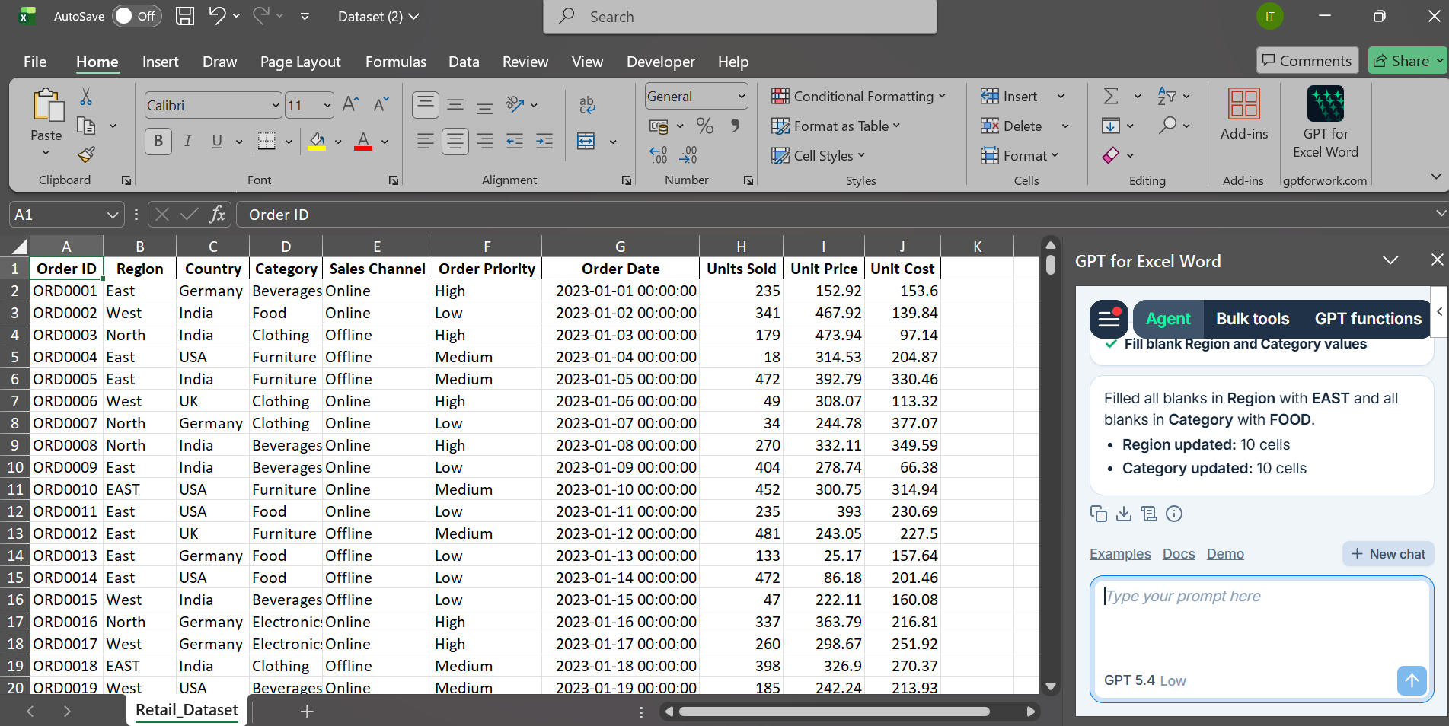
Here I filled missing values with EAST in Regions and FOOD in Category columns.
Q3.Fill missing numeric values in the Unit Sold and Unit Price columns.
SOL3: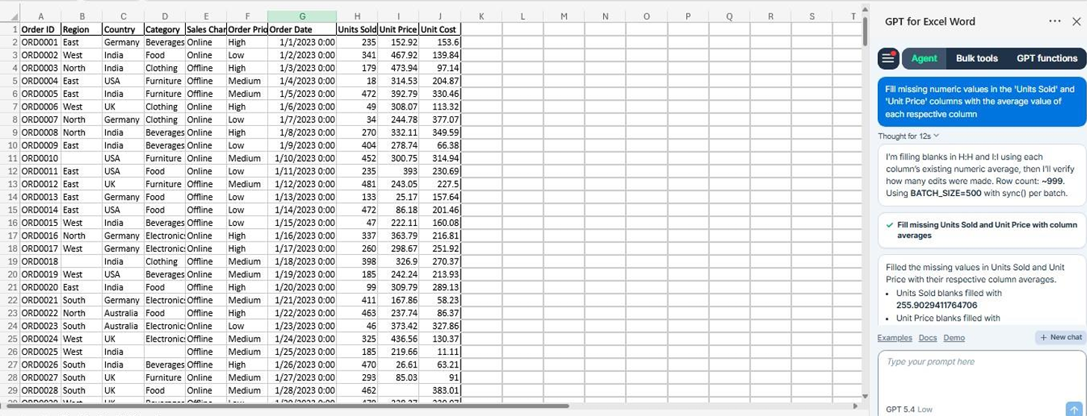
1)Units Sold blanks filled with 255.9029411764706
2) Unit Price blanks filled with 249.64520588235297
3) 659 blanks were filled in each column

Q4. Create a new calculated column Total Revenue.
SOL4: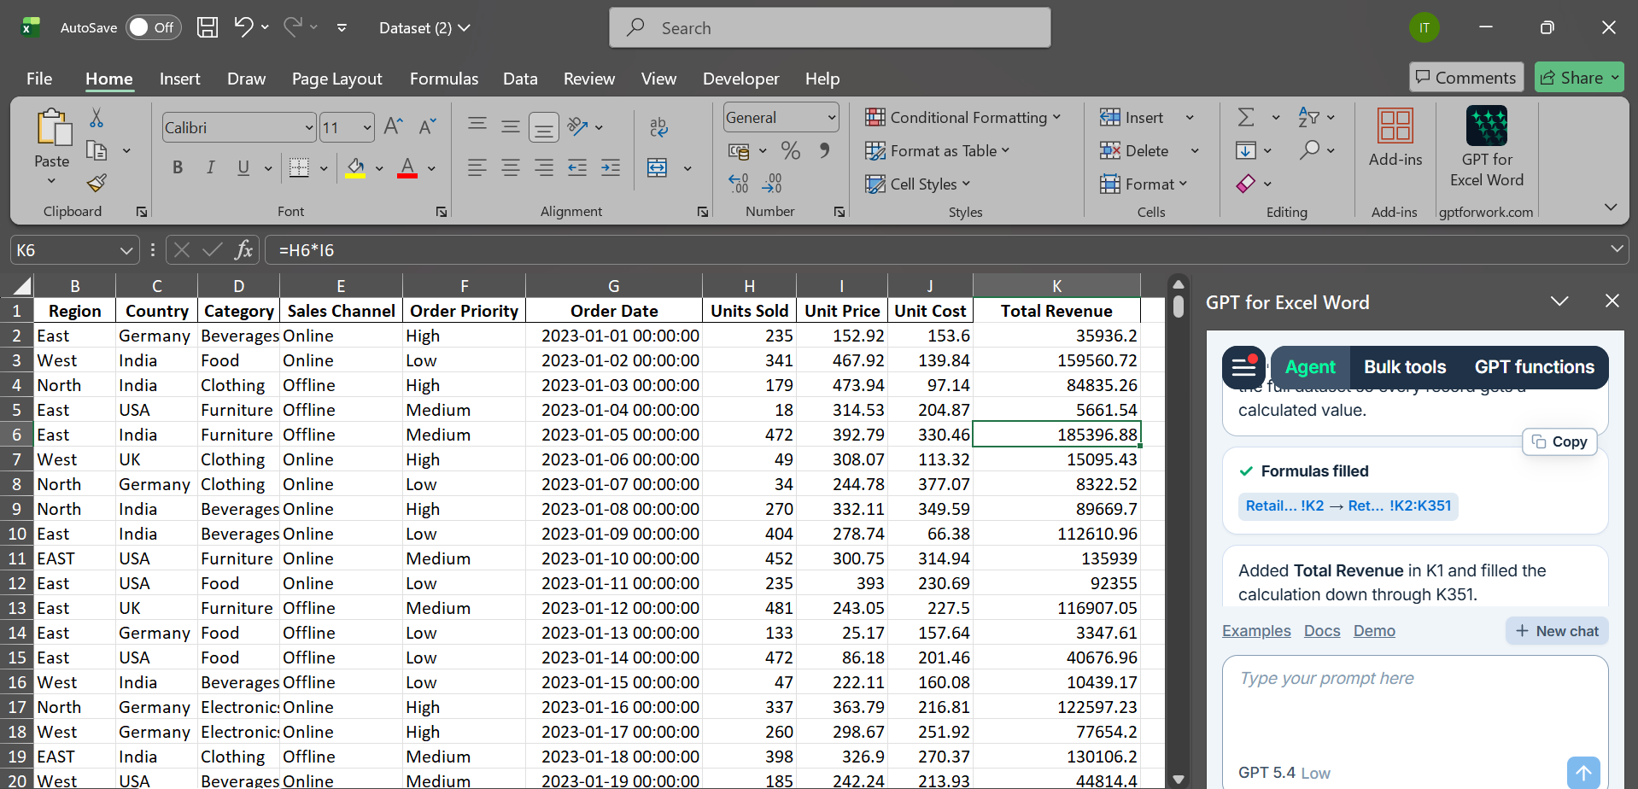
Here it used the formula Unit sold * Unit Price to find the Total Revenue.
Q5. Use Copilot to find the total price of Order ID = ‘ORD0123’.
SOL5: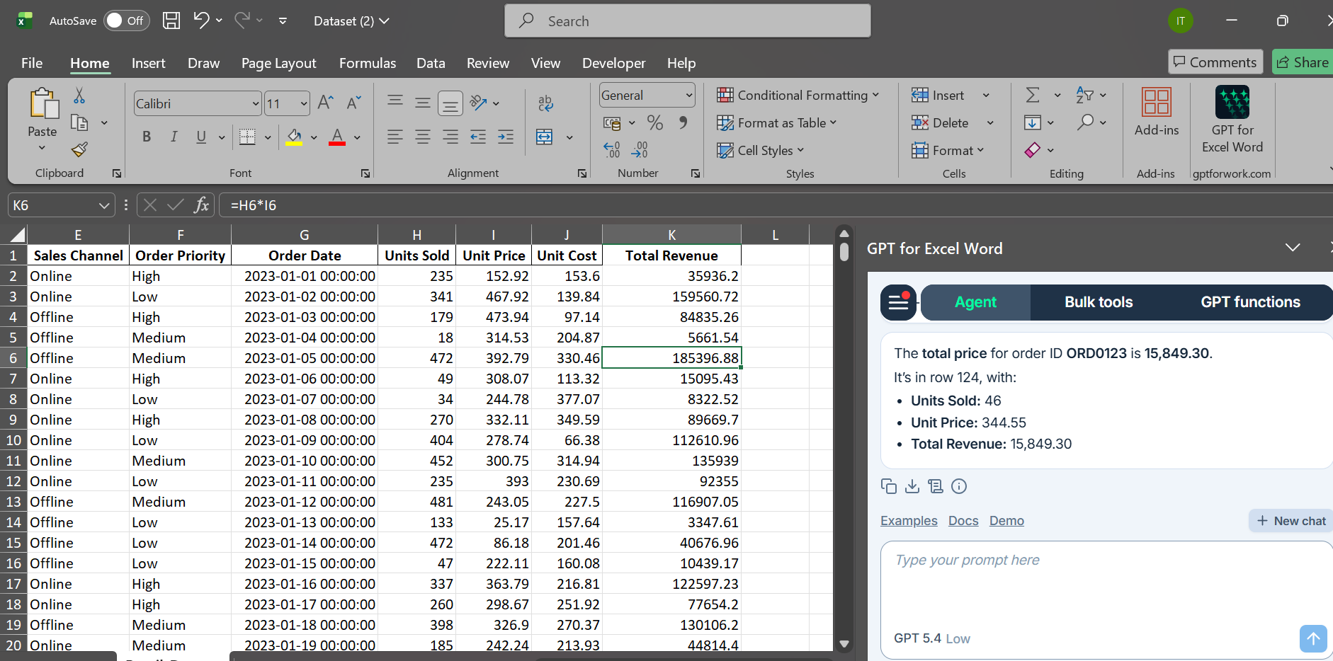
The total revenue for the order ID ORD0123 is 15,849.30
Q6. Use Copilot to generate a summary chart of average profit by region.
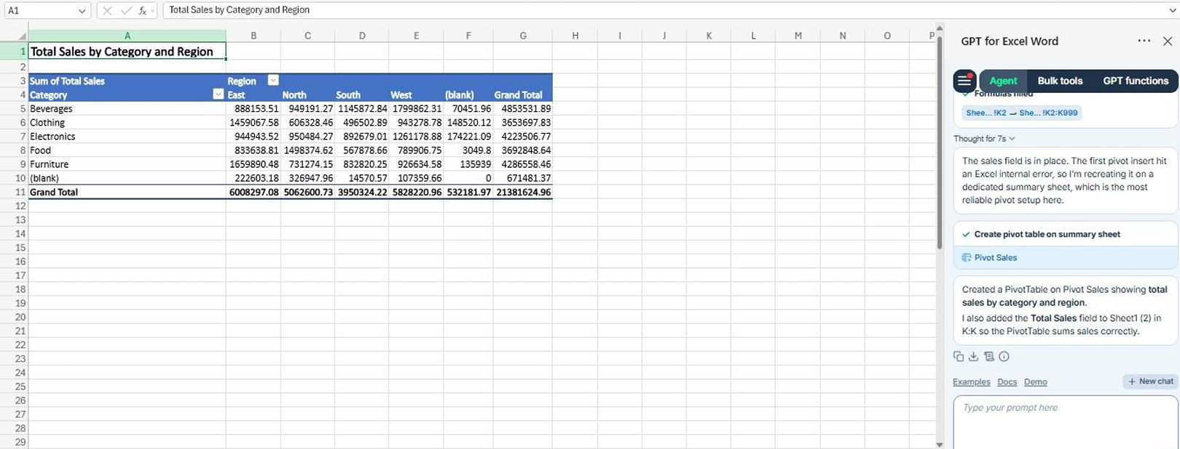
Created a PivotTable on Pivot Sales showing Total sales by category and region.
Q7. Create a pivot table summarizing total sales by category and region.
SOL7: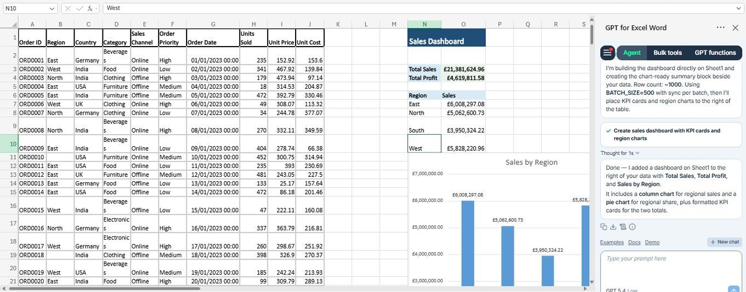
Added a dashboard to the right of the data with Total Sales, Total Profit, and Sales by Region.
Q8. Use Co-pilot to generate a summary report.
SOL8: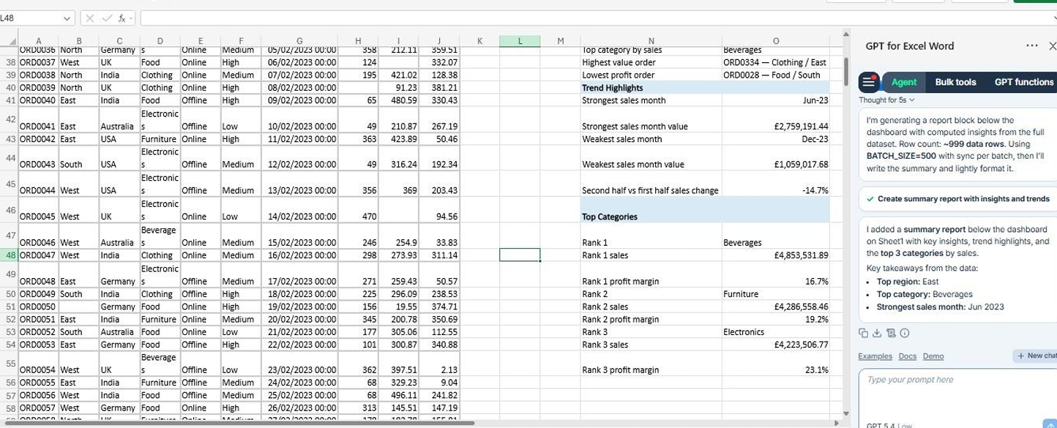
Added a Summary report with key insights, trend highlights, and the Top 3 categories by sales.
Top region: East
Top category: Beverages
Strongest sales month: Jun 2023

